实验报告

Task1

Frequency Analysis Against Monoalphabetic Substitution Cipher

1.创建一个article.txt和test.txt文件

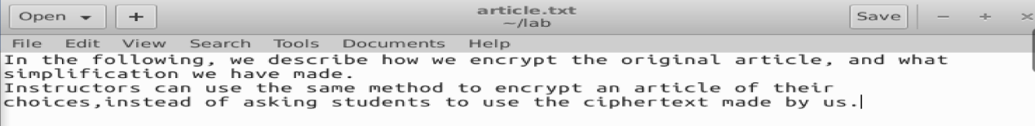

2.用tr替换命令把大写换成小写

$ tr [:upper:] [:lower:] < article.txt > lowercase.txt

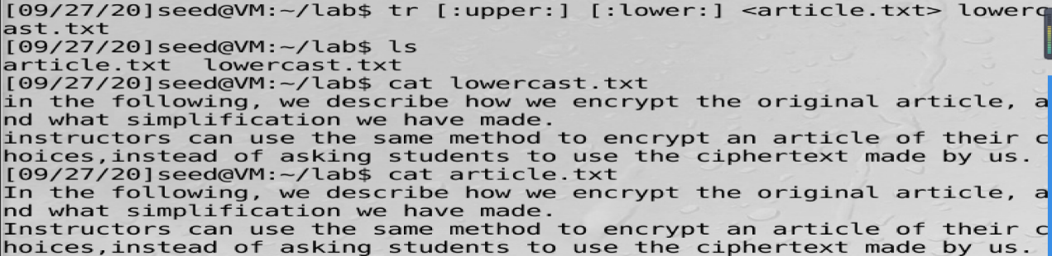

3.把标点符号和数字去掉



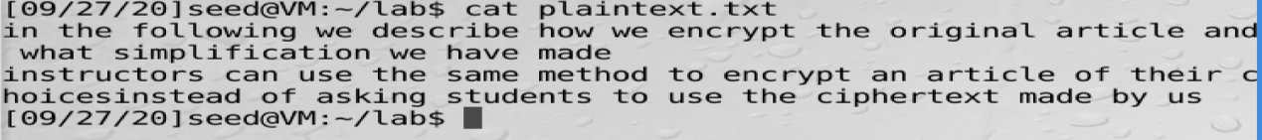

3.用python编码产生替换用的字符串

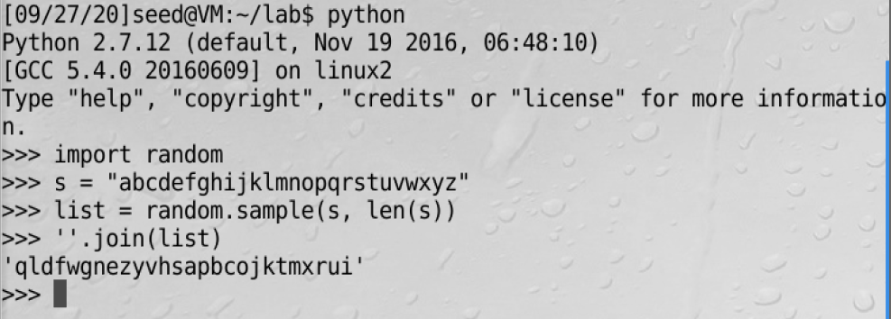

4.tr命令通过替换进行加密

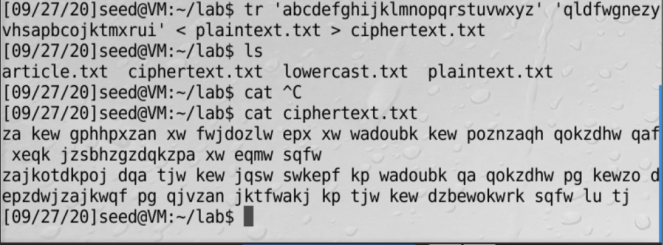

5.在工具网站上分析密文中字母出现的频率

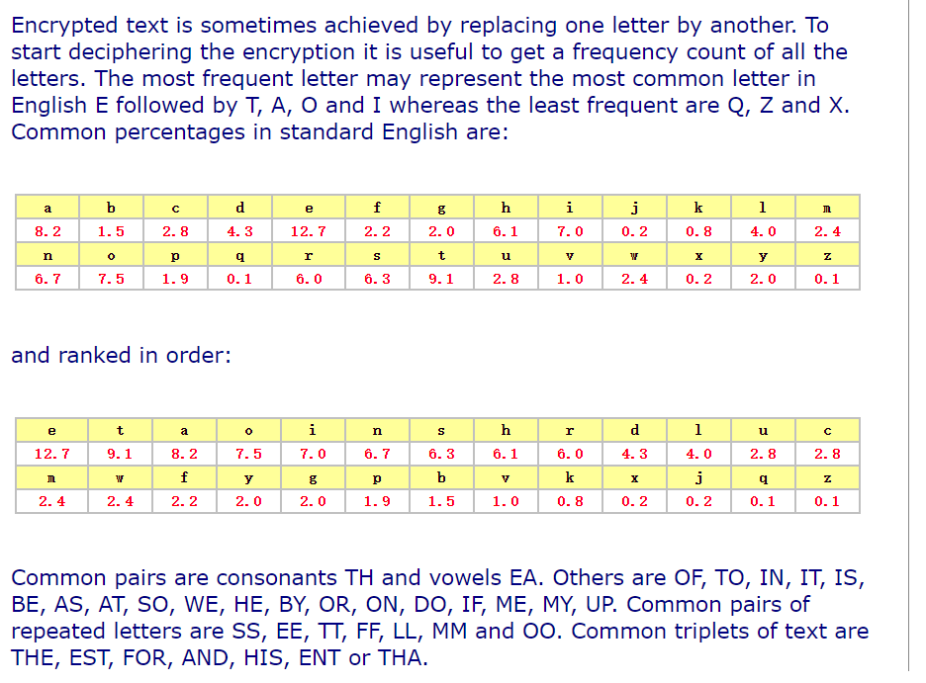6.将群里的密文输入分析网站

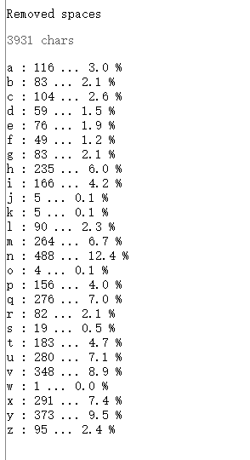 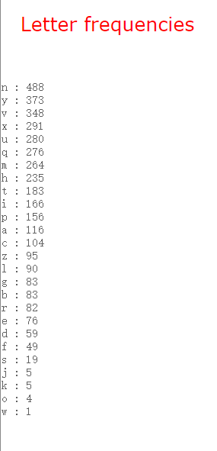 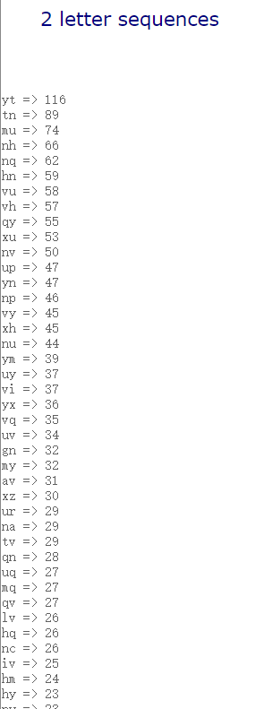 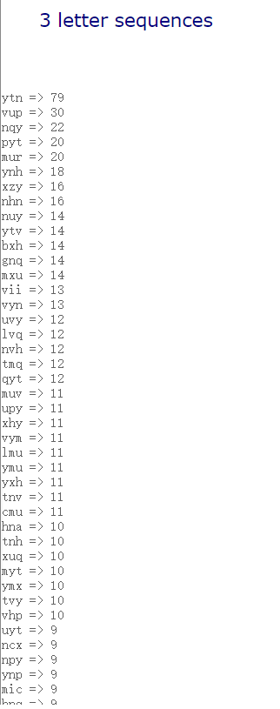

7.对比频率表

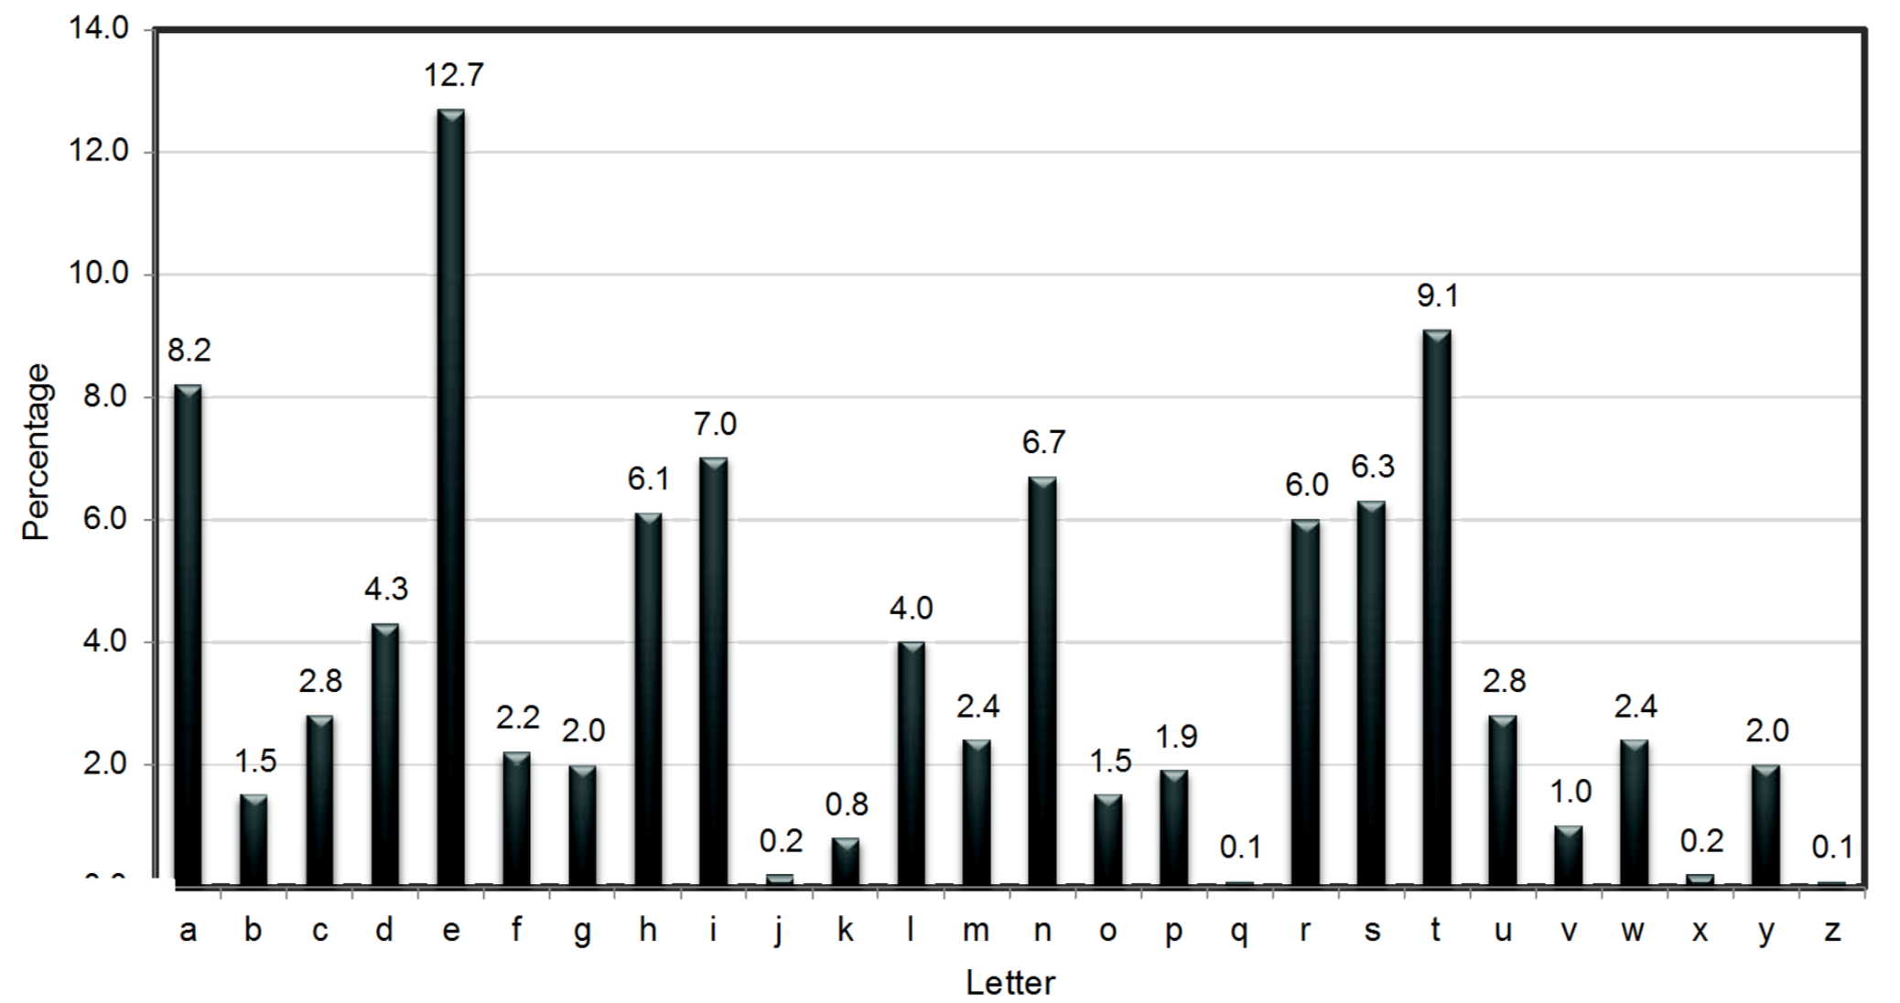

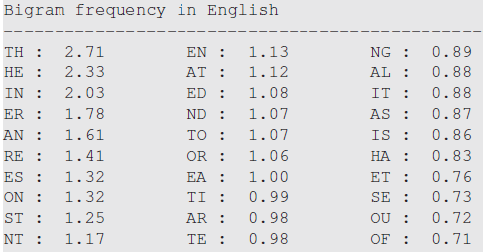

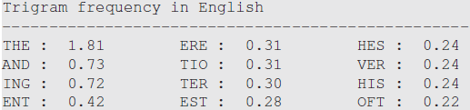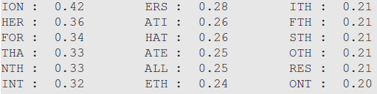

对比分析明文密文表：

明文 密文

E N

Y T

N H

T Y

O X

N U

A V

H T

R H

F B

S Q

L I

I M

G R

D P

M C

K S

U C

Y D

X K

W L

P E

B G

V F

Q J

Z O

8.tr 'nyvtxuhbqimrpcszadklegfjo' 'ETAHONRFSLIGDMKUCYXWPBVQZ' <article2.txt> out.txt

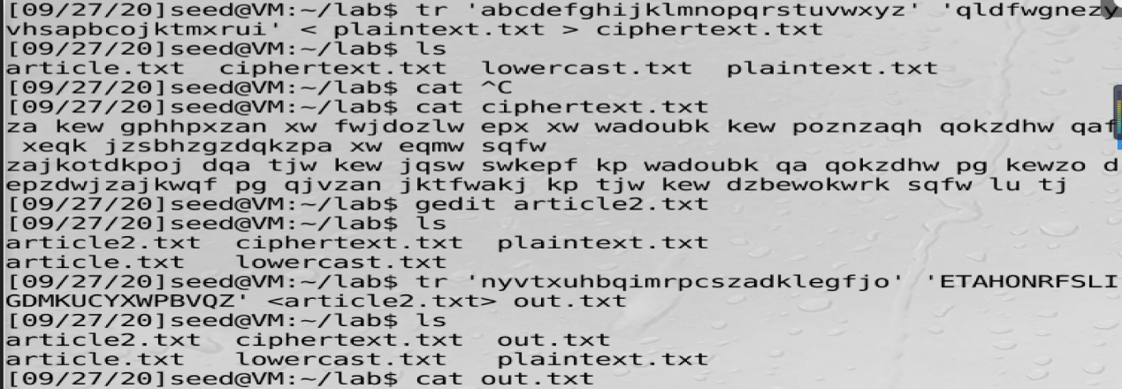

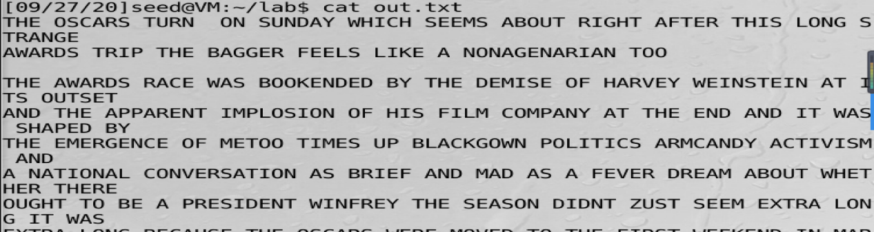

9.得出具体明文如下：

THE OSCARS TURN ON SUNDAY WHICH SEEMS ABOUT RIGHT AFTER THIS LONG STRANGE AWARDS TRIP THE BAGGER FEELS LIKE A NONAGENARIAN TOO

THE AWARDS RACE WAS BOOKENDED BY THE DEMISE OF HARVEY WEINSTEIN AT ITS OUTSET AND THE APPARENT IMPLOSION OF HIS FILM COMPANY AT THE END AND IT WAS SHAPED BY THE EMERGENCE OF METOO TIMES UP BLACKGOWN POLITICS ARMCANDY ACTIVISM AND A NATIONAL CONVERSATION AS BRIEF AND MAD AS A FEVER DREAM ABOUT WHETHER THERE OUGHT TO BE A PRESIDENT WINFREY THE SEASON DIDNT ZUST SEEM EXTRA LONG IT WAS EXTRA LONG BECAUSE THE OSCARS WERE MOVED TO THE FIRST WEEKEND IN MARCH TO AVOID CONFLICTING WITH THE CLOSING CEREMONY OF THE WINTER OLYMPICS THANKS PYEONGCHANG

ONE BIG QUESTION SURROUNDING THIS YEARS ACADEMY AWARDS IS HOW OR IF THE

CEREMONY WILL ADDRESS METOO ESPECIALLY AFTER THE GOLDEN GLOBES WHICH BECAME

A ZUBILANT COMINGOUT PARTY FOR TIMES UP THE MOVEMENT SPEARHEADED BY

POWERFUL HOLLYWOOD WOMEN WHO HELPED RAISE MILLIONS OF DOLLARS TO FIGHT SEXUAL

HARASSMENT AROUND THE COUNTRY SIGNALING THEIR SUPPORT GOLDEN GLOBES ATTENDEES SWATHED THEMSELVES IN BLACK SPORTED LAPEL PINS AND SOUNDED OFF ABOUT SEXIST POWER IMBALANCES FROM THE RED CARPET AND THE STAGE ON THE AIR E WAS CALLED OUT ABOUT PAY INEQUITY AFTER ITS FORMER ANCHOR CATT SADLER QUIT ONCE SHE LEARNED THAT SHE WAS MAKING FAR LESS THAN A MALE COHOST AND DURING THE CEREMONY NATALIE PORTMAN TOOK A BLUNT AND SATISFYING DIG AT THE ALLMALE ROSTER OF NOMINATED DIRECTORS HOW COULD

THAT BE TOPPED

AS IT TURNS OUT AT LEAST IN TERMS OF THE OSCARS IT PROBABLY WONT BE WOMEN INVOLVED IN TIMES UP SAID THAT ALTHOUGH THE GLOBES SIGNIFIED THE INITIATIVES LAUNCH THEY NEVER INTENDED IT TO BE ZUST AN AWARDS SEASON CAMPAIGN OR ONE THAT BECAME ASSOCIATED ONLY WITH REDCARPET ACTIONS INSTEAD

A SPOKESWOMAN SAID THE GROUP IS WORKING BEHIND CLOSED DOORS AND HAS SINCE AMASSED MILLION FOR ITS LEGAL DEFENSE FUND WHICH AFTER THE GLOBES WAS FLOODED WITH THOUSANDS OF DONATIONS OF OR LESS FROM PEOPLE IN SOME

COUNTRIES

NO CALL TO WEAR BLACK GOWNS WENT OUT IN ADVANCE OF THE OSCARS THOUGH THE MOVEMENT WILL ALMOST CERTAINLY BE REFERENCED BEFORE AND DURING THE CEREMONY ESPECIALLY SINCE VOCAL METOO SUPPORTERS LIKE ASHLEY ZUDD LAURA DERN AND NICOLE KIDMAN ARE SCHEDULED PRESENTERS

ANOTHER FEATURE OF THIS SEASON NO ONE REALLY KNOWS WHO IS GOING TO WIN BEST PICTURE ARGUABLY THIS HAPPENS A LOT OF THE TIME INARGUABLY THE NAILBITER

NARRATIVE ONLY SERVES THE AWARDS HYPE MACHINE BUT OFTEN THE PEOPLE FORECASTING THE RACE SOCALLED OSCAROLOGISTS CAN MAKE ONLY EDUCATED GUESSES

THE WAY THE ACADEMY TABULATES THE BIG WINNER DOESNT HELP IN EVERY OTHER

CATEGORY THE NOMINEE WITH THE MOST VOTES WINS BUT IN THE BEST PICTURE

CATEGORY VOTERS ARE ASKED TO LIST THEIR TOP MOVIES IN PREFERENTIAL ORDER IF A

MOVIE GETS MORE THAN PERCENT OF THE FIRSTPLACE VOTES IT WINS WHEN NO

MOVIE MANAGES THAT THE ONE WITH THE FEWEST FIRSTPLACE VOTES IS ELIMINATED AND ITS VOTES ARE REDISTRIBUTED TO THE MOVIES THAT GARNERED THE ELIMINATED BALLOTS SECONDPLACE VOTES AND THIS CONTINUES UNTIL A WINNER EMERGES

IT IS ALL TERRIBLY CONFUSING BUT APPARENTLY THE CONSENSUS FAVORITE COMES OUT AHEAD IN THE END THIS MEANS THAT ENDOFSEASON AWARDS CHATTER INVARIABLY INVOLVES TORTURED SPECULATION ABOUT WHICH FILM WOULD MOST LIKELY BE VOTERS SECOND OR THIRD FAVORITE AND THEN EQUALLY TORTURED CONCLUSIONS ABOUT WHICH FILM MIGHT PREVAIL

IN IT WAS A TOSSUP BETWEEN BOYHOOD AND THE EVENTUAL WINNER BIRDMAN

IN WITH LOTS OF EXPERTS BETTING ON THE REVENANT OR THE BIG SHORT THE

PRIwE WENT TO SPOTLIGHT LAST YEAR NEARLY ALL THE FORECASTERS DECLARED LA

LA LAND THE PRESUMPTIVE WINNER AND FOR TWO AND A HALF MINUTES THEY WERE

CORRECT BEFORE AN ENVELOPE SNAFU WAS REVEALED AND THE RIGHTFUL WINNER

MOONLIGHT WAS CROWNED

THIS YEAR AWARDS WATCHERS ARE UNEQUALLY DIVIDED BETWEEN THREE BILLBOARDS

OUTSIDE EBBING MISSOURI THE FAVORITE AND THE SHAPE OF WATER WHICH IS

THE BAGGERS PREDICTION WITH A FEW FORECASTING A HAIL MARY WIN FOR GET OUT

BUT ALL OF THOSE FILMS HAVE HISTORICAL OSCARVOTING PATTERNS AGAINST THEM THE SHAPE OF WATER HAS NOMINATIONS MORE THAN ANY OTHER FILM AND WAS ALSO NAMED THE YEARS BEST BY THE PRODUCERS AND DIRECTORS GUILDS YET IT WAS NOT NOMINATED FOR A SCREEN ACTORS GUILD AWARD FOR BEST ENSEMBLE AND NO FILM HAS WON BEST PICTURE WITHOUT PREVIOUSLY LANDING AT LEAST THE ACTORS NOMINATION

SINCE BRAVEHEART IN THIS YEAR THE BEST ENSEMBLE SAG ENDED UP GOING TO

THREE BILLBOARDS WHICH IS SIGNIFICANT BECAUSE ACTORS MAKE UP THE ACADEMYS

LARGEST BRANCH THAT FILM WHILE DIVISIVE ALSO WON THE BEST DRAMA GOLDEN GLOBE AND THE BAFTA BUT ITS FILMMAKER MARTIN MCDONAGH WAS NOT NOMINATED FOR BEST DIRECTOR AND APART FROM ARGO MOVIES THAT LAND BEST PICTURE WITHOUT ALSO EARNING BEST DIRECTOR NOMINATIONS ARE FEW AND FAR BETWEEN

Task2

维吉尼亚密码

1.使用字母出现频率的统计学原理

编写python程序，源码如下：

def findindexkey(subarr):

visiable_chars = [] # 可见字符

for x in range(32, 126):

visiable_chars.append(chr(x))

# print(vi)

test_keys = [] # 用于测试密钥

ans_keys = [] # 用于结果的返回

for x in range(0x00, 0xFF): # 枚举密钥里所有的值

test_keys.append(x)

ans_keys.append(x)

for i in test_keys: # 对于0x00~0xFF里的每一个数i和subarr里的每个值s异或

for s in subarr:

if chr(s ^ i) not in visiable_chars: # 用i解密s，如果解密后明文不是可见字符，说明i不是密钥

ans_keys.remove(i) # 去掉ans_keys里测试失败的密钥

break

# print(ans_keys)

return ans_keys

strmi = 'F96DE8C227A259C87EE1DA2AED57C93FE5DA36ED4EC87EF2C63AAE5B9A7EFFD673BE4ACF7BE8923C\

AB1ECE7AF2DA3DA44FCF7AE29235A24C963FF0DF3CA3599A70E5DA36BF1ECE77F8DC34BE129A6CF4D126BF\

5B9A7CFEDF3EB850D37CF0C63AA2509A76FF9227A55B9A6FE3D720A850D97AB1DD35ED5FCE6BF0D138A84C\

C931B1F121B44ECE70F6C032BD56C33FF9D320ED5CDF7AFF9226BE5BDE3FF7DD21ED56CF71F5C036A94D96\

3FF8D473A351CE3FE5DA3CB84DDB71F5C17FED51DC3FE8D732BF4D963FF3C727ED4AC87EF5DB27A451D47E\

FD9230BF47CA6BFEC12ABE4ADF72E29224A84CDF3FF5D720A459D47AF59232A35A9A7AE7D33FB85FCE7AF5\

923AA31EDB3FF7D33ABF52C33FF0D673A551D93FFCD33DA35BC831B1F43CBF1EDF67F0DF23A15B963FE5DA\

36ED68D378F4DC36BF5B9A7AFFD121B44ECE76FEDC73BE5DD27AFCD773BA5FC93FE5DA3CB859D26BB1C63C\

ED5CDF3FE2D730B84CDF3FF7DD21ED5ADF7CF0D636BE1EDB79E5D721ED57CE3FE6D320ED57D469F4DC27A8\

5A963FF3C727ED49DF3FFFDD24ED55D470E69E73AC50DE3FE5DA3ABE1EDF67F4C030A44DDF3FF5D73EA250\

C96BE3D327A84D963FE5DA32B91ED36BB1D132A31ED87AB1D021A255DF71B1C436BF479A7AF0C13AA14794'

arr = [] # 密文，每个元素为字符的ascii码

for x in range(0, len(strmi), 2):

arr.append(int(strmi[x:2 + x], 16))

for keylen in range(1, 14): # 枚举密钥的长度1~14

for index in range(0, keylen): # 对密钥里的第index个进行测试

subarr = arr[index::keylen] # 每隔keylen长度提取密文的内容，提取出来的内容都被密文的第index个加密

ans_keys = findindexkey(subarr) # 找出密钥中第index个的可能的值

print('keylen=', keylen, 'index=', index, 'keys=', ans_keys)

if ans_keys: # 如果密钥第index个有可能存在，尝试用密钥的index个去解密文

ch = []

for x in ans_keys:

ch.append(chr(x ^ subarr[0]))

print(ch)

# 运行到这里，观察输出可以发现，密钥长度为7时有解

print('###############')

import string

def findindexkey2(subarr): # 再造一个函数筛选密钥

test_chars = string.ascii_letters + string.digits + ',' + '.' + ' ' # 将检查的字符改为英文+数字+逗号+句号+空格

# print(test_chars)

test_keys = [] # 用于测试密钥

ans_keys = [] # 用于结果的返回

for x in range(0x00, 0xFF): # 枚举密钥里所有的值

test_keys.append(x)

ans_keys.append(x)

for i in test_keys: # 对于0x00~0xFF里的每一个数i和substr里的每个值s异或

for s in subarr:

if chr(s ^ i) not in test_chars: # 用i解密s，如果解密后不是英文、数字、逗号、句号、空格，说明i不是密钥

ans_keys.remove(i) # 去掉ans_keys里测试失败的密钥

break

# print(ans_keys)

return ans_keys

vigenerekeys = [] # 维基尼尔密码的密钥

for index in range(0, 7): # 已经知道密钥长度是7

subarr = arr[index::7]

vigenerekeys.append(findindexkey2(subarr))

print(vigenerekeys) # 输出的是[[186], [31], [145], [178], [83], [205], [62]].

print("#########")

ming = ''

for i in range(0, len(arr)):

ming = ming + chr(arr[i] ^ vigenerekeys[i % 7][0])

print(ming)

运行结果如图：

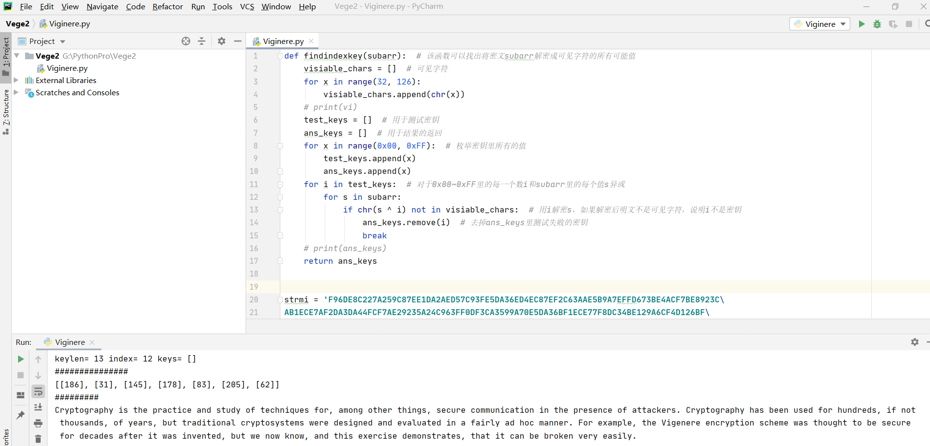

密钥如下：



明文如下：

Cryptography is the practice and study of techniques for, among other things, secure communication in the presence of attackers. Cryptography has been used for hundreds, if not thousands, of years, but traditional cryptosystems were designed and evaluated in a fairly ad hoc manner. For example, the Vigenere encryption scheme was thought to be secure for decades after it was invented, but we now know, and this exercise demonstrates, that it can be broken very easily.

Task3

破解重复的一次一密密码

1.通过异或运算和ASCII码的计算规律破解原始消息

BB3A65F6F0034FA957F6A767699CE7FABA855AFB4F2B520AEAD612944A801E  
BA7F24F2A35357A05CB8A16762C5A6AAAC924AE6447F0608A3D11388569A1E  
A67261BBB30651BA5CF6BA297ED0E7B4E9894AA95E300247F0C0028F409A1E  
A57261F5F0004BA74CF4AA2979D9A6B7AC854DA95E305203EC8515954C9D0F  
BB3A70F3B91D48E84DF0AB702ECFEEB5BC8C5DA94C301E0BECD241954C831E  
A6726DE8F01A50E849EDBC6C7C9CF2B2A88E19FD423E0647ECCB04DD4C9D1E  
A6726DE8F01A50E849EDBC6C7C9CF2B2A88E19FD423E0647ECCB04DD4C9D1E  
BC7570BBBF1D46E85AF9AA6C7A9CEFA9E9825CFD5E3A0047F7CD009305A71E

Python程序源码

import binascii  
import argparse  
  
SPACE = ord(**' '**)  
  
  
def countalphas(char, position, ciphertexts):  
 count = 0  
 for ciphertext in ciphertexts:  
 if len(ciphertext) > position:  
 if chr(ciphertext[position] ^ char).isalpha(): count += 1  
 return count  
  
  
def main():  
 parser = argparse.ArgumentParser(description=**"Many-time Pad Cracker"**)  
 parser.add_argument(**"--filename"**, type=str,  
 help=**"Name of the file containing the ciphertexts (default: ciphertexts.txt)"**,  
 default=**"ciphertexts.txt"**)  
 args = parser.parse_args()  
 try:  
 with open(args.filename) as f:  
 ciphertexts = [binascii.unhexlify(line.rstrip()) for line in f]  
 *# Cyphertexts puliti (tolgo i vuoti), anche se non è necessario  
 # ciphertexts = [c for c in ciphertexts if c]* cleartexts = [bytearray(b'?' * len(c)) for c in ciphertexts]  
 except Exception as e:  
 print(**"Cannot crack {} --- {}"**.format(args.filename, e))  
 raise SystemExit(-1)  
  
 *# 'a'.isalpha() => true  
 # '!'.isalpha() => false  
 # ord('z') => 122* for col in range(max([len(x) for x in ciphertexts])):  
 for c1 in ciphertexts:  
 for c2 in ciphertexts:  
 if (len(c1) > col) and (len(c2) > col):  
 if chr(c1[col] ^ c2[col]).isalpha():  
 for k, c in enumerate(ciphertexts):  
 if len(c) > col:  
 if countalphas(c1[col], col, ciphertexts) >= countalphas(c2[col], col, ciphertexts):  
 cleartexts[k][col] = c1[col] ^ 0b100000 ^ c[col]  
 else:  
 cleartexts[k][col] = c2[col] ^ 0b100000 ^ c[col]  
  
 break  
  
 for line in cleartexts:  
 print(line)  
  
  
if __name__ == **"__main__"**:  
 main()

密文以及明文输出结果如下：

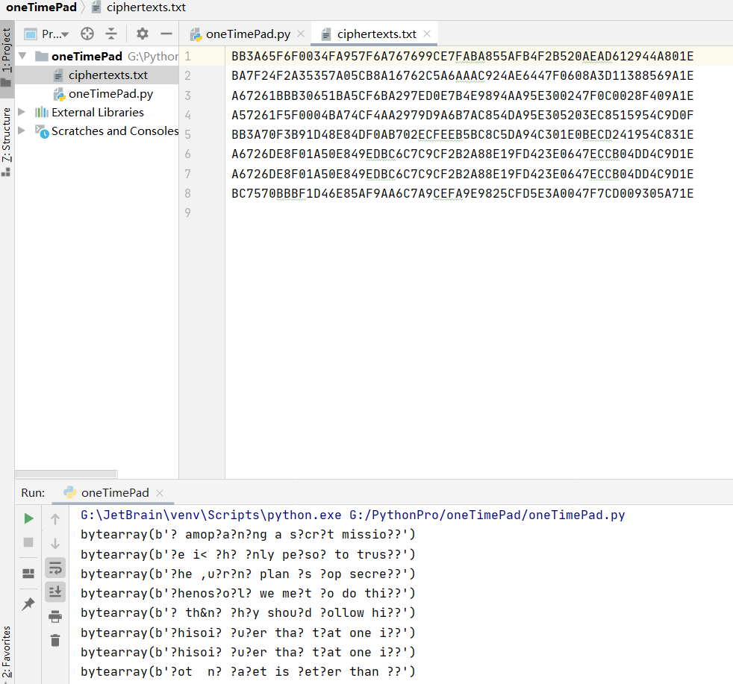

补全缺失字母后，最终得到明文：

I am planning a secret mission.

He is the only person to trust.

The current plan is top secret.

When should we meet to do this?

I think they should follow him.

This is purer than that one is.

Not one cadet is better than I.